Context-Aware Intrusion Response in Smart Grids: Integrating Explainable Al with Physics-Informed Graph RAG
Course: ECE2500Y: M.Eng. Project
Student: Jiakai Tang
Supervisor: Prof. Deepa Kundur, Dr. Ahmad Abdelsamie
Mentor: Charlotte Fritz

Table of Contents
Problem Statement 1
Objective 2
Proposed Methodology and Architecture 2
Layer 1: Baseline Intrusion Detection 2
Layer 2: The XAI Attribution Layer 3
Layer 3: The Semantic Layer (Multi-Persona LightRAG Knowledge Graph Integration) 3
Evaluation strategy – The CAPS Metric 3
Experiment design 4

Problem Statement
As power grids evolve into highly connected Cyber-Physical Systems (CPS), machine learning models are increasingly deployed to detect anomalies and secure critical electrical infrastructure. While these models effectively identify latent attack vectors within high-dimensional network traffic, a critical bottleneck exists in how they communicate findings to distinct stakeholders.
When a machine learning Intrusion Detection System (IDS) flags an anomaly, standard Explainable AI (XAI) tools—such as SHAP or LIME—are typically deployed to justify the alert. However, these traditional XAI techniques fundamentally fail in Operational Technology (OT) environments for three structural reasons:
- Lack of Topological Awareness: Standard XAI operates purely in the mathematical feature space. It can attribute an anomaly to a specific feature (e.g., identifying a variance in IEC 104 ASDU TypeID 46), but it has no spatial awareness of the physical grid. It cannot map that packet to the physical RTU or Feeder Breaker it controls.
- Lack of Cascading/Prognostic Capability: Current feature-attribution models are strictly diagnostic (backward-looking). They explain why the model fired, but they cannot forecast the downstream physical consequences of the event (e.g., a resulting thermal overload), which is critical for operator triage.
- Role-Agnostic Output: Standard XAI outputs raw mathematical weights. This creates a semantic gap across the organization:
  - An OT Operator requires physical triage commands, not feature weights.
  - A Data Scientist requires model validation metrics, not hardware instructions.
  - A Manager/Regulator requires compliance and business impact summaries.
Because traditional XAI algorithms cannot dynamically translate mathematical anomalies into the native domain language or topological reality of the specific user, trust erodes and triage efficiency collapses. Current literature evaluates algorithmic fidelity but largely fails to address this multi-persona operational usefulness.

Objective
My research project aims to design explanation quality measures based strictly on user cognitive needs, proposing and validating new metrics that correlate directly with decision-making utility across different organizational roles.
To bridge the semantic gap, this project proposes a contextualizer utilizing a LightRAG knowledge graph architecture. By leveraging LightRAG's dual-level retrieval capabilities over a heterogeneous knowledge base, the system will dynamically translate mathematical feature weights into actionable, role-specific intelligence for relevant stakeholder and consumer of the intrusion detection model and XAI outputs.

Proposed Methodology and Architecture
The design utilizes an orchestrated pipeline designed to maximize semantic richness while minimizing computational overhead.
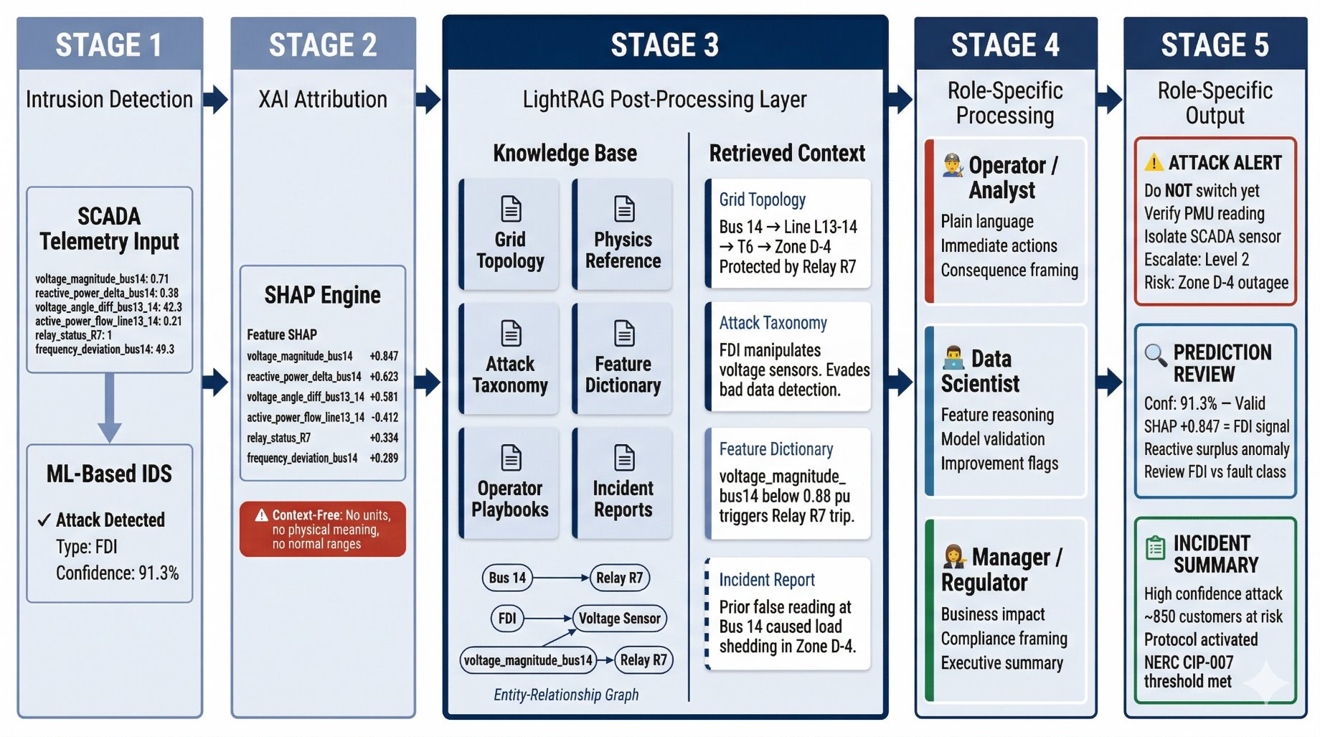

Layer 1: Baseline Intrusion Detection
- Dataset: The project utilizes an IEC 60870-5-104 (IEC 104) dataset containing raw telecontrol network traffic from real-life data (attack-free) and lab simulated attack data.
- Detection Model: A Random Forest classifier will be trained to detect anomalies based on the network traffic. At this foundational tier, the output is strictly a binary classification (Attack/Normal) alongside a mathematical confidence score, offering zero diagnostic context to the end-user.

Layer 2: The XAI Attribution Layer
- Feature Importance Engine: To unpack the "black box" prediction from Tier 1, SHapley Additive explanations (SHAP) will be applied to the Random Forest model.
- Mathematical Context: Upon detection of an anomaly, the SHAP engine outputs the raw mathematical weights of the top contributing features (e.g., highlighting a variance on ASDU_TypeID_46). While this provides algorithmic transparency for debugging, it remains topologically blind and role-agnostic.

Layer 3: The Semantic Layer (Multi-Persona LightRAG Knowledge Graph Integration)
To translate the abstract SHAP features from Tier 2 into actionable, role-specific context, an efficient prompt-routing architecture will be implemented:
- The Heterogeneous Knowledge Graph: A Neo4j database will ingest multiple document types: physical Grid Topology (mapping IOAs to field devices), Attack Taxonomies, Operator Playbooks, Feature Dictionaries, and Incident Reports (optional).
- Unified Retrieval: Upon detection, the orchestrator utilizes LightRAG to send a single query to the graph, extracting a comprehensive Multi-Domain Context Block containing both local physical mappings and broader community summaries (e.g., playbook rules).
- The Prompt Routing Loop (Synthesizer): A single local Large Language Model (operating strictly at temperature=0 to minimize variance) executes a prompt routing loop. It processes the exact same retrieved context block three times, dynamically swapping the System Prompt to generate tailored outputs for the Operator, Data Scientist, and Regulator or any additional stakeholders.

Evaluation strategy – The CAPS Metric
To rigorously quantify operational usefulness, this project introduces the Contextual Persona Actionability Score (CPAS). This generalized framework evaluates generated explanations across mutually exclusive dimensions of user cognition:
$$CPAS=w_{1}D+w_{2}C+w_{3}A+w_{4}R-λH$$
- $D$ (Domain Grounding): Accuracy of the present-state root cause within the user's specific domain
- $C$ (Cascading Impact): Accuracy of the forecasted downstream trajectory based on the user's area of concern.
- $A$ (Actionability): Clarity and executability of the suggested intervention.
- $R$ (Role Resonance): Adherence to the user's native vocabulary and formatting.
- $H$ (Hallucination Detection): A binary penalty( $H= 0 or 1$) triggering the severe $λ$ deduction if domain-specific assets or policies are invented.
The evaluation utilizes an LLM-as-a-Judge to simulate human stakeholders. The Judge evaluates explanations using a strict 1-to-5 rubric for the core dimensions, ensuring consistent, quantitative outputs.
Rubric Abstraction (Example mappings):
- Score 5 (Excellent): Flawless domain mapping; exact downstream forecast; binary, executable command; zero off-domain jargon.
- Score 3 (Good): Identifies general domain area; vague forecast; suggests intervention but dilutes with noise; mixed vocabulary requiring cognitive filtering.
- Score 1 (Poor): Complete domain mismatch; no forecast; purely diagnostic with no action; entirely wrong persona vocabulary.
The Judge will independently score Hallucination Detection. If the explanation references a node, edge, or rule not explicitly present in the provided Multi-Domain Context Block, $H=1$ triggering the penalty multiplier.

Experiment design
The experiment utilizes a controlled 3-Tier A/B/C testing methodology across a curated sample of 15 scenarios (5 True Positive Cyber, 5 True Positive Physical, 5 False Positive Noise).
Evaluation Tier | System Configuration | Expected Finding
1. Baseline | IDS Output Only (Raw prediction + confidence score). No context. | Triage accuracy is effectively random; CPAS scores uniformly low across all personas.
2. XAI | IDS + XAI (Raw SHAP feature attribution added). Context-free. | Minor improvement in domain grouding for Data Scientists. Operator and Regulator CPAS remain critically low due to the persistent Semantic Gap.
3. Proposed System | IDS + XAI + LightRAG + Prompt Routing Loop. | Significant CPAS maximization across all three personas. Actionability and Role resonance scores improve dramatically due to role-specific vocabulary and targeted interventions.

